Assignment-6.4
Task 1: Student Performance Evaluation System
Scenario : You are building a simple academic management module for a university system where student performance needs to be evaluated automatically.
# Prompt :
1 - I want to create a program that manages student performance by taking input for multiple students including their names, roll numbers and marks. In tabular format.
2 - Check the students marks above the class average and return their names and roll numbers with marks and appreciation message.

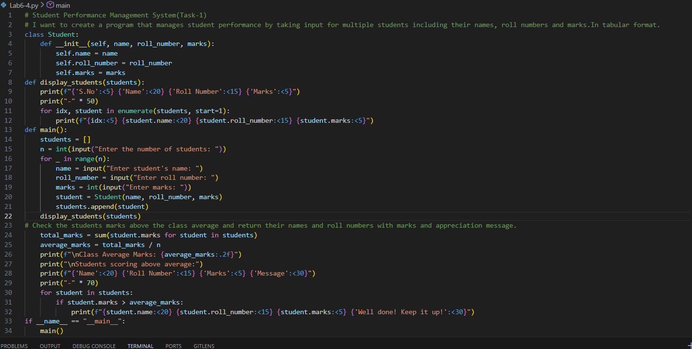
Output :
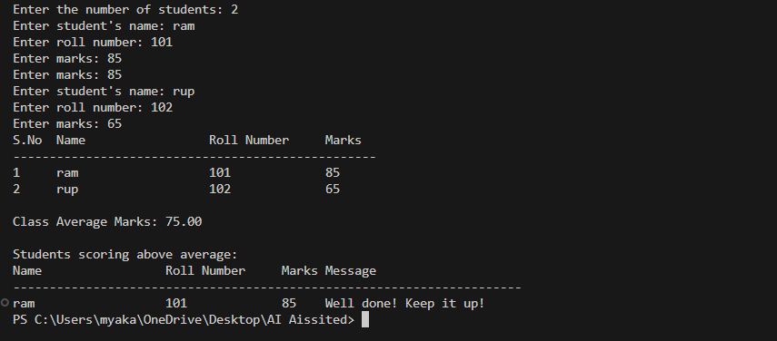
Task 2: Data Processing in a Monitoring System
# Prompt: 1- I want to create a program that takes sensor data readings over a period of time and processes them, Identify even numbers from the readings and calculate their squares.
2- Return the list of numbers along with their squares in a tabular format.

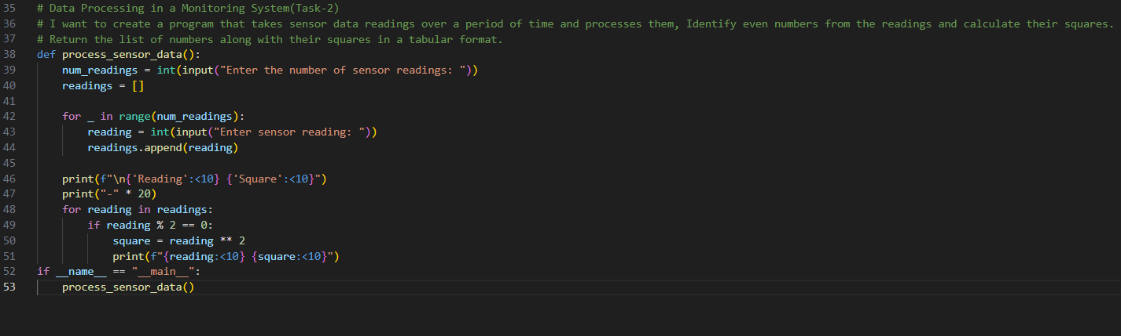
Output:
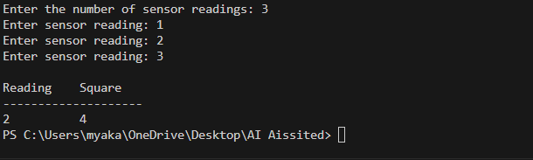
Task 3: Banking Transaction Simulation
Prompt:
# I want to create a program that simulates banking module that handles deposits, withdrawals and balance inquiries.
# Take account holder's name, initial balance
# Prevent overdrafts during withdrawals and provide appropriate messages for each transaction.
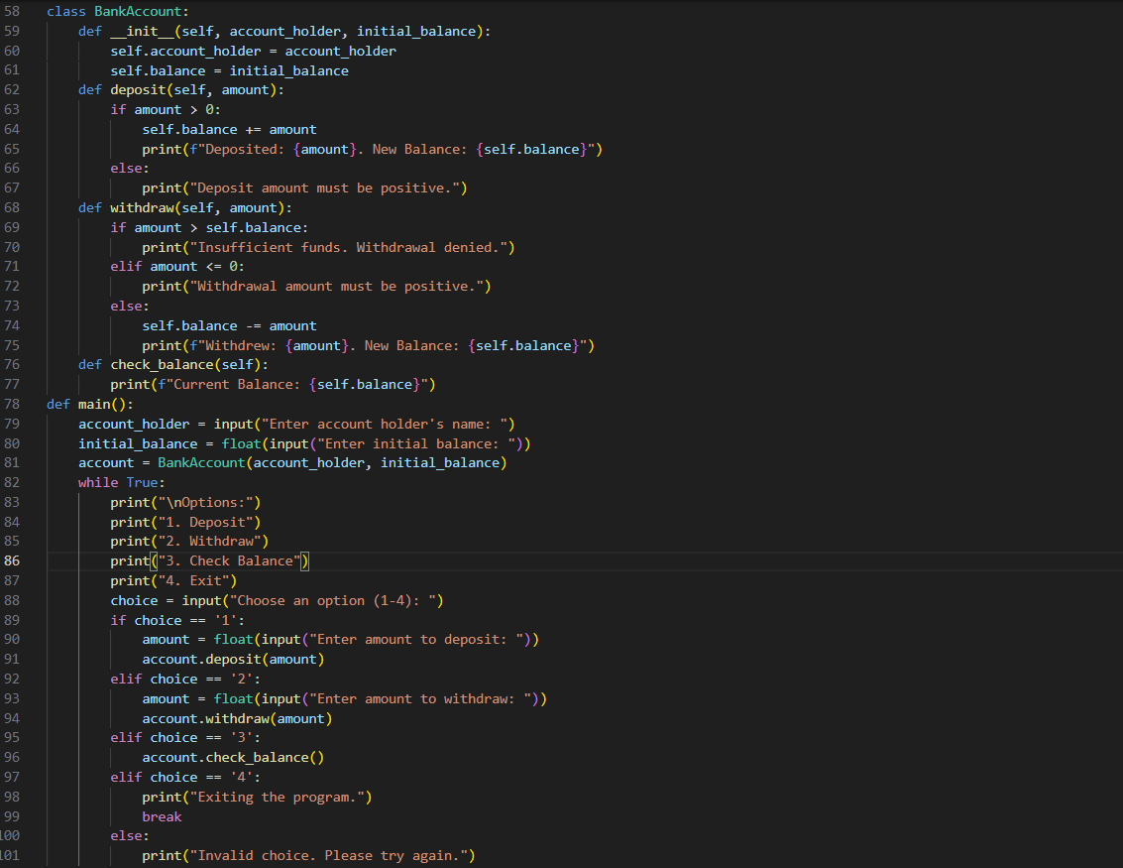
Output:
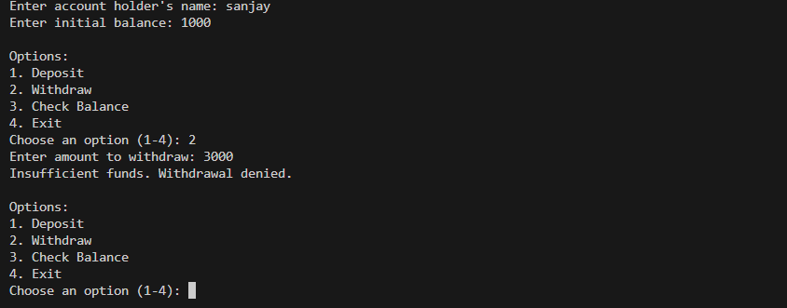
Task 4: Student Scholarship Eligibility Check
Prompt:
# I want to create a program that checks the eligibility of students for a scholarship based on their scores.
# Take input for student name, roll number and score.Iterates through the list.
# Print the names who scored more than 75.
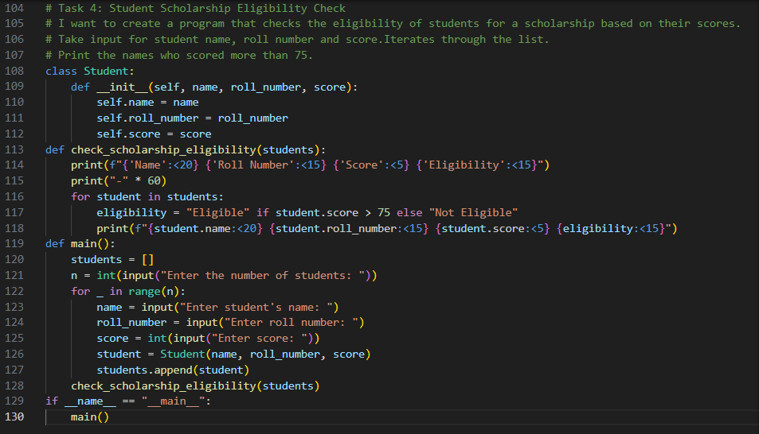
Output:
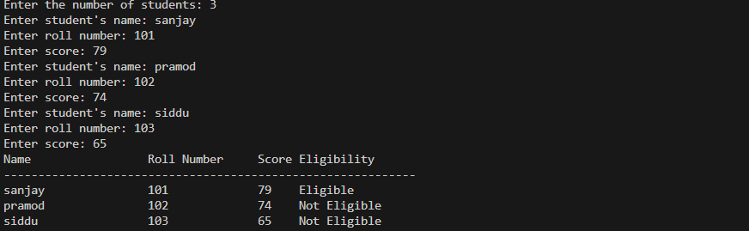
Task 5: Online Shopping Cart Module
Prompt:
# I want to create a program that simulates an online shopping cart An empty list to store items(name ,price and quantity).
# Allow users to add items to the cart,remove items from the cart.
# Calculate the total cost of items in the cart using a loop.Apply conditional discounts if total exceeds a certain amount.

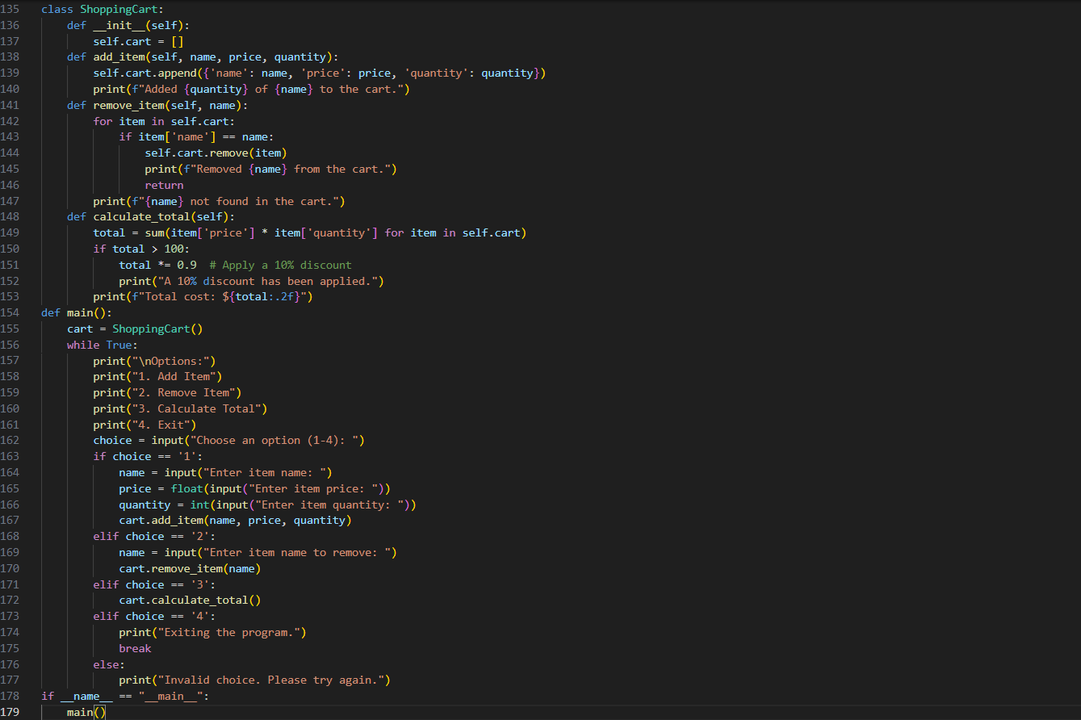
Output:
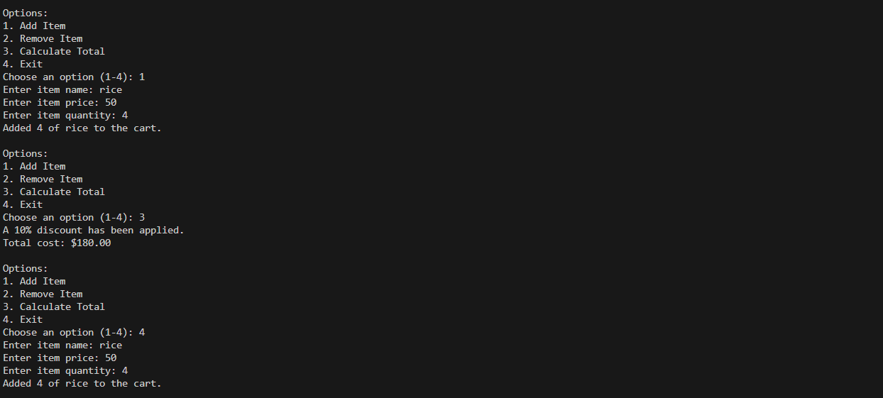

CODE EXPLANATION:
Task 1: Bank Account Management System
# This task involves creating a class `BankAccount` with methods to deposit, withdraw, and check balance.
# The main function allows users to interact with the account through a menu-driven interface.
Task 2: Temperature Conversion Utility
# This task involves creating functions to convert temperatures between Celsius and Fahrenheit.
# The main function allows users to choose the conversion type and input temperature values.
Task 3: Student Grade Calculator
# This task involves creating a class `Student` with methods to calculate grades based on scores.
# The main function allows users to input student details and calculates grades accordingly.
Task 4: Student Scholarship Eligibility Check
# This task involves creating a class `Student` and checking eligibility for scholarships based on scores.
# The main function collects student details and displays eligibility status for each student.
Task 5: Online Shopping Cart Module
# This task involves creating a `ShoppingCart` class that manages items in an online shopping cart.
# It allows adding, removing, and calculating the total cost of items in the cart.

